Ferris Social Emotional Learning (SEL) Parent Night Resources

* UBC Mind Matters article: [https://magazine.alumni.ubc.ca/2022/fall-](https://magazine.alumni.ubc.ca/2022/fall-2022/careers/mind-matters) [2022/careers/mind-matters](https://magazine.alumni.ubc.ca/2022/fall-2022/careers/mind-matters)
* CASEL – Social and Emotional Learning: [https://casel.org/fundamentals-of-sel/what-is-](https://casel.org/fundamentals-of-sel/what-is-the-casel-framework/) [the-casel-framework/](https://casel.org/fundamentals-of-sel/what-is-the-casel-framework/)
* Dr. Mark Bracket – Permission to Feel: Unlocking the Power of Emotions (Mood Meter)
* Dr. Carol Dweck – Mindset: Changing the Way You Think to Fulfill Your Potential
* Zones of Regulation: <https://zonesofregulation.com/>

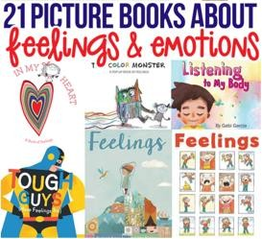List of books to learn about feelings: [https://childhood101.com/books-](https://childhood101.com/books-about-emotions/) [about-emotions/](https://childhood101.com/books-about-emotions/)

Talk about the emotions of characters in books: “Look at his face. What do you think he's feeling? Oh, you think he looks mad. Yes, he could be mad or maybe even furious. His face is red and his hands are in fists!"

How to enjoy nature with kids: <https://www.beafunmum.com/2012/05/ways-to-enjoy-nature-with-kids/>

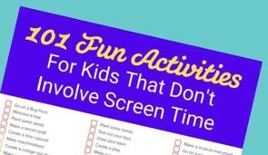Screen Free activities to do with your child: [https://www.mykidstime.com/things-to-do/101-fun-activities-for-kids-](https://www.mykidstime.com/things-to-do/101-fun-activities-for-kids-dont-involve-screen-time/) [dont-involve-screen-time/](https://www.mykidstime.com/things-to-do/101-fun-activities-for-kids-dont-involve-screen-time/)

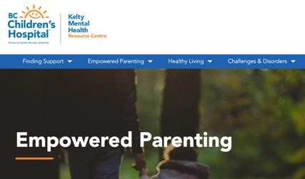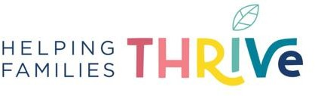 <https://helpingfamiliesthrive.com/blog/> <https://biglifejournal.com/blogs/blog>

<https://keltymentalhealth.ca/empowered-parenting> Social Emotional Development -

<https://keltymentalhealth.ca/social-emotional-development>