Ferris Falcons – School Wear

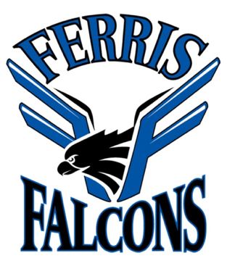
Dear Ferris Families,

Ferris Falcon wear is for sale and is a great way for students to show their school spirit. There are several different items available for ordering. Each item features the Ferris Falcons logo (attached). This is not a fundraiser. We have tried to keep the cost low to allow for more students to purchase Falcon wear! Parents – you are welcome to order some Ferris Wear for yourselves, as well! Orders will open on Thu. Oct. 20 on SchoolCashOnline.

Ordering Deadline – Monday, October 31st , 2022

We hope for orders to be sent home with students before Winter Break

Please place orders through Schoolcash Online: https://richmondsd38.schoolcashonline.com/

Sizing
Please click on the links below to see a sample picture of each item and their sizing charts.

Youth short-sleeved t-shirt (silkscreened logo on front)

Youth pullover hoodie (silkscreened logo on front)

Youth full-zip hoodie (embroidered logo on left chest)

Adult short-sleeved t-shirt (silkscreened logo on front)

Adult pullover hoodie (silkscreened logo on front)

Adult full-zip hoodie (embroidered logo on left chest)

Sincerely,
Julianna Ng
Vice Principal, Ferris School

If you do not want to receive email communication from Ferris School, please contact the office.

